LOAD BALANCER
1. Configure Classic Load balancer.
2. Configure Application Load balancer.
3. Configure Network Load balancer.
4. Attach SSL for application load balancer.
5. Map Application load balancer to R53.
6. Push the application load balancer logs to S3

Task 1: Configure Classic Load Balancer (CLB)
AWS Classic Load Balancer is a legacy load balancer. For new projects, AWS generally recommends Application Load Balancer (ALB) or Network Load Balancer (NLB). However, CLB is still useful for learning and understanding older AWS architectures.
Objective :
The objective is to configure an AWS Classic Load Balancer to distribute incoming traffic across multiple EC2 instances.

Architecture
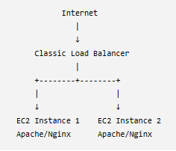

Prerequisites :

AWS resources required
- AWS Account
- VPC
- At least 2 EC2 instances
  - Preferably in different Availability Zones.
- Web server installed
  - Apache or Nginx.
- Security Groups
  - Load Balancer security group
  - EC2 security group
- Two Availability Zones
  - Example:
  - ap-south-1a
ap-south-1b

Step-by-Step Implementation

Step 1: Launch EC2 Instance 1
Go to:
AWS Console → EC2 → Instances → Launch instance
Choose:
Name: WebServer-1
AMI: Amazon Linux
Instance type: t2.micro/t3.micro
VPC: Your VPC
Subnet: Subnet-1
Configure the security group.
Allow:
HTTP TCP 80 from 0.0.0.0/0
SSH TCP 22 from your IP
Launch the instance
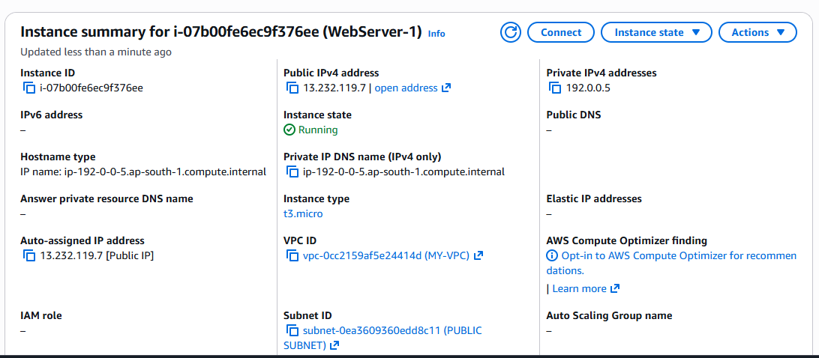

Step 2: Install Apache on EC2-1
Connect to EC2-1 using SSH.
sudo dnf install httpd -y
Start Apache:
sudo systemctl start httpd
Enable it at boot:
sudo systemctl enable httpd
Create a test page:
echo "Hello from WebServer-1" | sudo tee /var/www/html/index.html
Check:
curl localhost
Expected:
Hello from WebServer-1

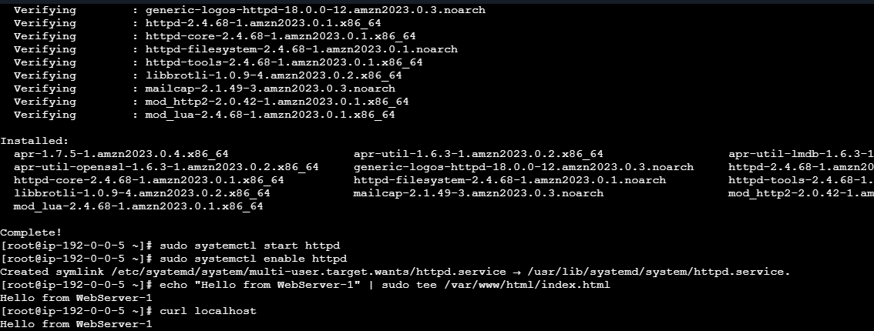

Step 3: Launch EC2 Instance 2
Launch another EC2 instance.
Use:
Name: WebServer-2
AMI: Amazon Linux
Instance type: t2.micro/t3.micro
Subnet: Subnet-2
Ideally place it in another Availability Zone.
Install Apache:
sudo dnf install httpd -y
sudo systemctl start httpd
sudo systemctl enable httpd
Create a different page:
echo "Hello from WebServer-2" | sudo tee /var/www/html/index.html
Test:
curl localhost
Expected:
Hello from WebServer-2

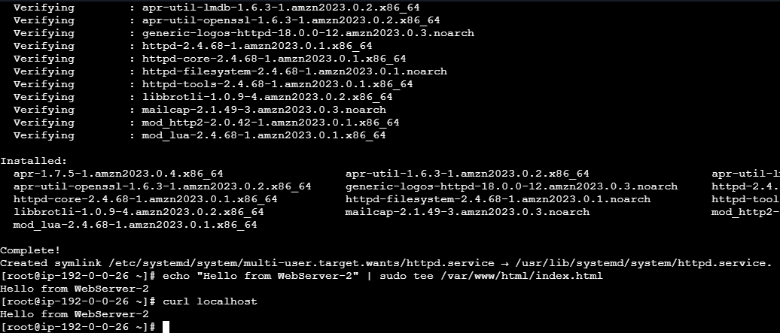

Step 4: Configure EC2 Security Group
This is important.
For the initial lab, you can allow HTTP:
Type: HTTP
Port: 80
Source: 0.0.0.0/0
For a more secure architecture, allow port 80 from the Load Balancer's security group, rather than from the entire internet.
Conceptually:
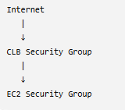

Step 5: Create Classic Load Balancer
Go to:
AWS Console → EC2 → Load Balancers
Click:
Create Load Balancer
Select:
Classic Load Balancer
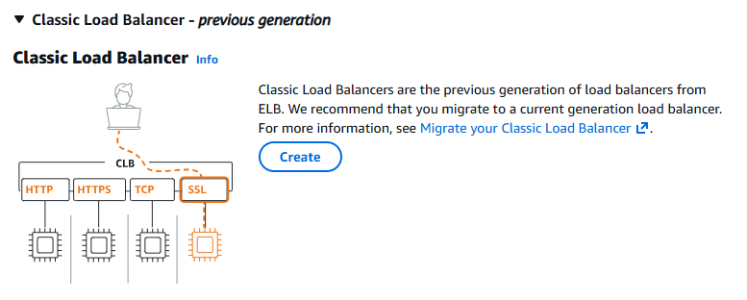

Step 6: Configure Basic Load Balancer Settings
Example:
Load Balancer name:
my-classic-lb
Scheme:
Internet-facing
Listener:
Load Balancer Protocol: HTTP
Load Balancer Port: 80

Instance Protocol: HTTP
Instance Port: 80
So:
Client
|
| HTTP :80
↓
CLB
|
| HTTP :80
↓
EC2

Step 7: Select VPC and Subnets
Select your VPC.
Then select the required Availability Zones/subnets.
For example:
ap-south-1a → Subnet-1
ap-south-1b → Subnet-2
This gives the load balancer access to both EC2 instances.

Step 8: Configure Security Group
Create/select the security group for the CLB.
Allow:
HTTP
TCP
80
Source: 0.0.0.0/0
For SSH, you generally do not need to allow SSH to the load balancer.

Step 9: Configure Health Check
Configure the health check.
Example:
Ping Protocol: HTTP
Ping Port: 80
Ping Path: /
Example settings:
Healthy threshold: 2
Unhealthy threshold: 2
Timeout: 5 seconds
Interval: 30 seconds
The CLB periodically checks:
CLB
|
+----> EC2-1 :80 /
|
+----> EC2-2 :80 /
If EC2-1 stops responding correctly:
EC2-1 → Unhealthy
The CLB stops sending normal traffic to that instance.

Step 10: Register EC2 Instances
Select:
WebServer-1
WebServer-2
Add/register them with the load balancer.
You should eventually see:
Classic Load Balancer
|
+---- WebServer-1 → InService
|
+---- WebServer-2 → InService
Wait until both instances become:
InService
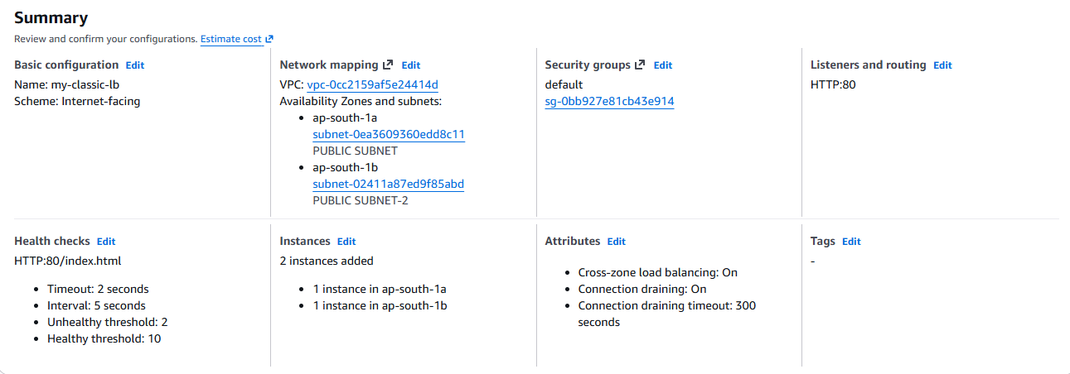

Step 11: Create the Load Balancer
Review the configuration and click:
Create Load Balancer
AWS will provide a DNS name similar to:
my-classic-lb-123456789.ap-south-1.elb.amazonaws.com
Do not use the EC2 public IP to test the load balancer.

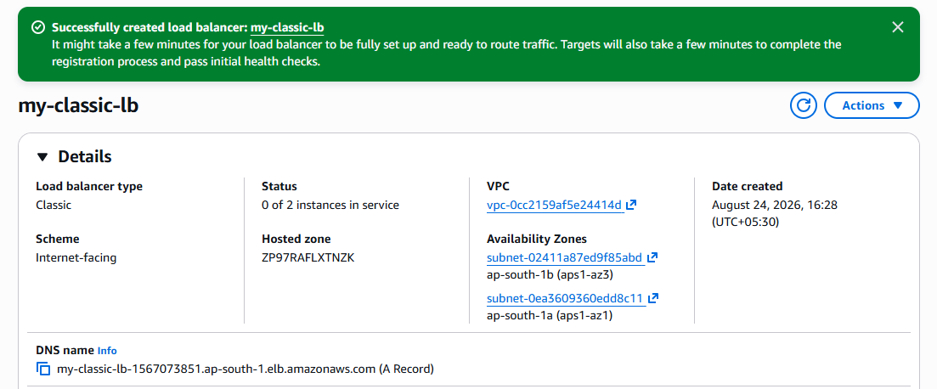

Step 12: Test the Load Balancer
Copy the CLB DNS name and open:
http://<CLB-DNS-NAME>
You should receive a response from one of your web servers.
For example:
Hello from WebServer-1
The CLB distributes requests among the registered healthy instances.





Step 13: Test Health Check
Now stop Apache on EC2-1:
sudo systemctl stop httpd
The CLB health check will detect that EC2-1 is unhealthy.
You should eventually see:
WebServer-1 → OutOfService
WebServer-2 → InService
The CLB will send traffic to the healthy server.
Start Apache again:
sudo systemctl start httpd
After the health checks succeed:
WebServer-1 → InService
Final Architecture
Internet
|
| HTTP :80
↓
+-----------------------+
| Classic Load Balancer |
| Port 80 |
+-----------+-----------+
|
+---------+---------+
| |
↓ ↓
+---------------+ +---------------+
| EC2-1 | | EC2-2 |
| Apache | | Apache |
| Port 80 | | Port 80 |
+---------------+ +---------------+
| |
+--------+----------+
|

Health Checks

2.Configure Application Load Balancer (ALB)

Objective :
The objective is to configure an AWS Application Load Balancer (ALB) to distribute HTTP/HTTPS application traffic across multiple EC2 instances.

What we achieve
- Distribute traffic across multiple EC2 instances.
- Improve application availability and scalability.
- Perform health checks on EC2 instances.
- Route traffic based on host names or URL paths.
- Support HTTP and HTTPS.
- Integrate with Auto Scaling Groups.

Architecture

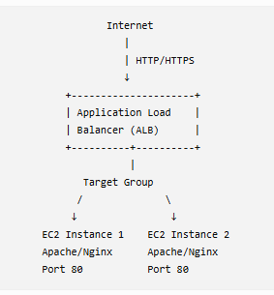

Prerequisites :
Before creating the ALB, make sure you have:

1. AWS Account
You need an AWS account with permissions for:
- EC2
- Elastic Load Balancing
- VPC
- Security Groups

2. VPC
A VPC should be available.
Example:
VPC: 10.0.0.0/16

3. Two Subnets
For high availability, use subnets in two different Availability Zones.
Example:
ap-south-1a → 10.0.1.0/24
ap-south-1b → 10.0.2.0/24
For an internet-facing ALB, these should be public subnets with a route to an Internet Gateway.

4. Two EC2 Instances
Launch at least two EC2 instances:
EC2-1 → AZ-1 → Apache/Nginx
EC2-2 → AZ-2 → Apache/Nginx

5. Web Server
Install Apache or Nginx on both instances.
For Amazon Linux:
sudo dnf install httpd -y
sudo systemctl start httpd
sudo systemctl enable httpd
Create different pages so you can identify which server responded:
EC2-1:
echo "Hello from Server 1" | sudo tee /var/www/html/index.html
EC2-2:
echo "Hello from Server 2" | sudo tee /var/www/html/index.html

6. Security Groups
You should ideally create two security groups:
ALB-SG
↓
EC2-SG
ALB-SG:
HTTP 80 0.0.0.0/0
EC2-SG:
HTTP 80 ALB-SG
This is better than allowing HTTP from the entire internet directly to the EC2 instances.

Step-by-Step Implementation

Step 1: Open Load Balancers
Go to:
AWS Console → EC2 → Load Balancers
Click:
Create Load Balancer
You will see options such as:
Application Load Balancer
Network Load Balancer
Gateway Load Balancer
Select:
Application Load Balancer
Click Create.

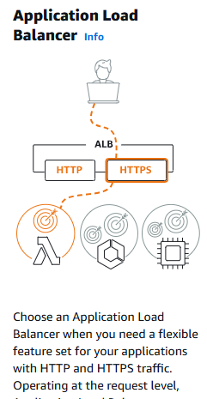

Step 2: Configure Basic ALB Settings
Enter:
Load Balancer name:
my-application-lb

Scheme
Select:
Internet-facing
This is used when clients from the internet need to access your application.
For an internal application, select:
Internal

IP address type
For a basic lab:
IPv4

Step 3: Configure Network Mapping
Select your VPC.
Example:
VPC: My-VPC
Select at least two Availability Zones.
Example:
Availability Zone 1:
ap-south-1a
Subnet: Public-Subnet-1

Availability Zone 2:
ap-south-1b
Subnet: Public-Subnet-2
Architecture:
ALB
/ \
/ \
Public Subnet Public Subnet
AZ-1 AZ-2
| |
EC2-1 EC2-2

Step 4: Configure Security Group
Select or create:
ALB-SG
Inbound rule:
Type: HTTP
Protocol: TCP
Port: 80
Source: 0.0.0.0/0
For HTTPS later:
Type: HTTPS
Port: 443
Source: 0.0.0.0/0

Step 5: Configure Listener
The listener defines where the ALB receives incoming traffic.
For this lab:
Protocol: HTTP
Port: 80
Default action:
Forward to → Target Group
But first we need to create the target group.

Step 6: Create Target Group
Go to:
EC2 → Target Groups → Create target group
Select target type:
Instances
Target group name:
my-web-target-group
Protocol:
HTTP
Port:
80
VPC:
Your VPC

Step 7 : Configure Health Check
Configure:
Health check protocol: HTTP
Health check path: /
Example:
Protocol: HTTP
Port: Traffic port
Path: /
The ALB will periodically send requests such as:
GET /
to the EC2 instances.
If the instance responds successfully:
EC2-1 → Healthy
If it fails:
EC2-1 → Unhealthy
The ALB will stop sending normal traffic to the unhealthy target.

Step 8: Register EC2 Instances
Select your EC2 instances:
☑ EC2-1
☑ EC2-2
Set:
Port: 80
Click:
Include as pending below
Then click:
Create target group
You should eventually see:
Target Group
|
+---- EC2-1 → Healthy
|
+---- EC2-2 → Healthy

Step 9: Attach Target Group to ALB
Return to:
EC2 → Load Balancers → Create Application Load Balancer
Under listener:
HTTP : 80
Select:
Forward to:
my-web-target-group
So the traffic flow becomes:
Client
|
| HTTP :80
↓
ALB
|
↓
Target Group
|
+-------- EC2-1 :80
|
+-------- EC2-2 :80

Step 10: Create ALB
Review the configuration.
Click:
Create Load Balancer
AWS will create an ALB DNS name similar to:
my-application-lb-123456789.ap-south-1.elb.amazonaws.com

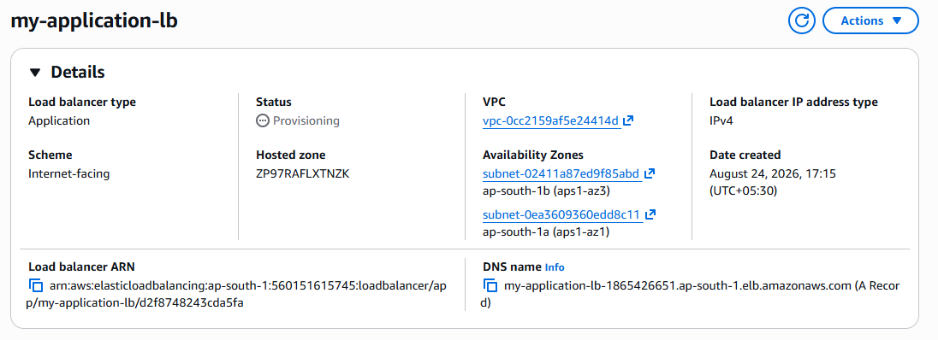

Step 11: Test the ALB
Copy the ALB DNS name.
Open:
http:// my-application-lb-1865426651.ap-south-1.elb.amazonaws.com
You should see:
Hello from Server 1
or:
Hello from Server 2
The ALB distributes requests among healthy targets.
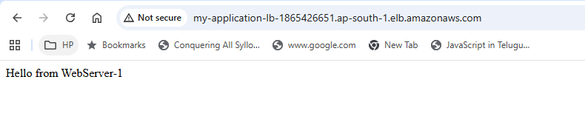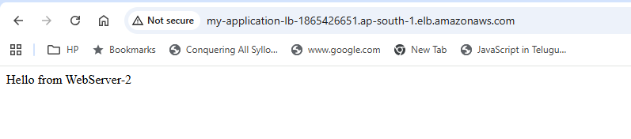

Step 12: Verify Target Health
Go to:
EC2 → Target Groups → my-web-target-group → Targets
You should see:
Instance Port Health
------------------------------------
EC2-1 80 Healthy
EC2-2 80 Healthy
If one instance becomes unhealthy:
Instance Port Health
------------------------------------
EC2-1 80 Unhealthy
EC2-2 80 Healthy
The ALB sends traffic only to the healthy target.
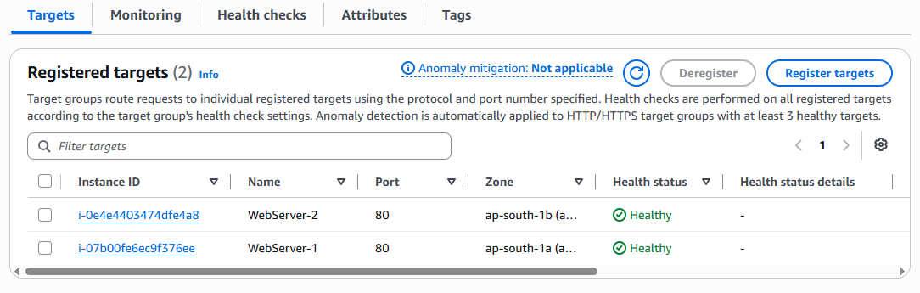

Step 13: Test Failover
On EC2-1:
sudo systemctl stop httpd
Wait for the health check to detect the failure.
You should eventually see:
EC2-1 → Unhealthy
EC2-2 → Healthy
Now access the ALB DNS name again.
Traffic will be directed to:
ALB
|
└── EC2-2
Start Apache again:
sudo systemctl start httpd
After successful health checks:
EC2-1 → Healthy
EC2-2 → Healthy

Final Architecture
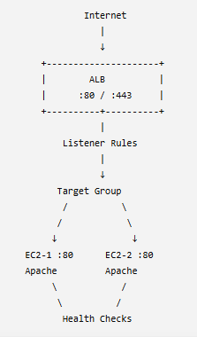

3. Configure Network Load balancer

Objective :
The objective is to configure an AWS Network Load Balancer (NLB) to distribute TCP/UDP/TLS traffic across multiple EC2 instances.
NLB operates at Layer 4 (Transport Layer) and is suitable when you need high performance, low latency, static IP support, or protocols other than HTTP/HTTPS.

Architecture
Internet
|
|
TCP :80
|
↓
+-------------------+
| Network Load |
| Balancer (NLB) |
+---------+---------+
|
Target Group
/ \
↓ ↓
EC2-1 EC2-2
:80 :80

Prerequisites :
Before creating the NLB, prepare the following.

1. AWS Account
You need permissions for:
- EC2
- Elastic Load Balancing
- VPC
- Security Groups

2. VPC
Example:
VPC: 10.0.0.0/16

3. Two Subnets
For high availability, use subnets in different Availability Zones.
ap-south-1a → Subnet-1
ap-south-1b → Subnet-2

4. Two EC2 Instances
Launch:
EC2-1 → AZ-1
EC2-2 → AZ-2
Install a web server such as Apache.
sudo dnf install httpd -y
sudo systemctl start httpd
sudo systemctl enable httpd
Create different test pages.
EC2-1:
echo "Hello from NLB Server 1" | sudo tee /var/www/html/index.html
EC2-2:
echo "Hello from NLB Server 2" | sudo tee /var/www/html/index.html
Test locally:
curl localhost

Configure Security Group
For the EC2 instances, allow the port on which your application is running.
For this lab:
Type: HTTP
Port: 80
Source: 0.0.0.0/0
In a production environment, restrict the source appropriately.
NLB itself does not require a security group in the same way an ALB does; whether traffic is controlled by security groups depends on the NLB configuration and target type. For this basic EC2 lab, focus on allowing the application port on the targets.

Step-by-Step Implementation

Step 1: Open Load Balancers
Go to:
AWS Console → EC2 → Load Balancers
Click:
Create Load Balancer
You will see:
Application Load Balancer
Network Load Balancer
Gateway Load Balancer
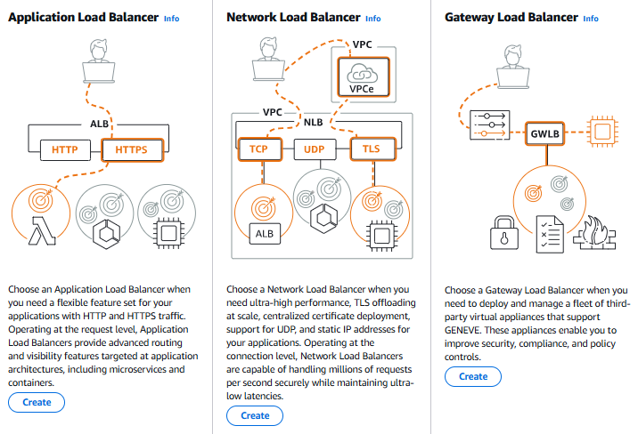
Select:
Network Load Balancer
Click Create.

Step 2: Configure Basic NLB Settings
Enter:
Load Balancer name:
my-network-lb

Scheme
Select:
Internet-facing
This allows clients on the internet to access the NLB.
For an internal application, you can select:
Internal

IP address type
For this lab:
IPv4

Step 3: Configure Network Mapping
Select your VPC:
My-VPC
Select subnets from at least two Availability Zones.
Example:
ap-south-1a → Public-Subnet-1
ap-south-1b → Public-Subnet-2
Architecture:
NLB
/ \
/ \
AZ-1 AZ-2
| |
EC2-1 EC2-2

Step 4: Configure Listener
The listener determines which protocol and port the NLB accepts.
For this lab, use TCP.
Protocol: TCP
Port: 80
Traffic flow:
Client
|
| TCP :80
↓
NLB :80
|
↓
Target Group
|
+---- EC2-1 :80
|
+---- EC2-2 :80

Why TCP?
Because NLB works at Layer 4 and can forward TCP connections without understanding HTTP URLs.

Step 5: Create Target Group
Create a new target group.
Select:
Target type:
Instances
Target group name:
my-nlb-target-group
Protocol:
TCP
Port:
80
Select your VPC.
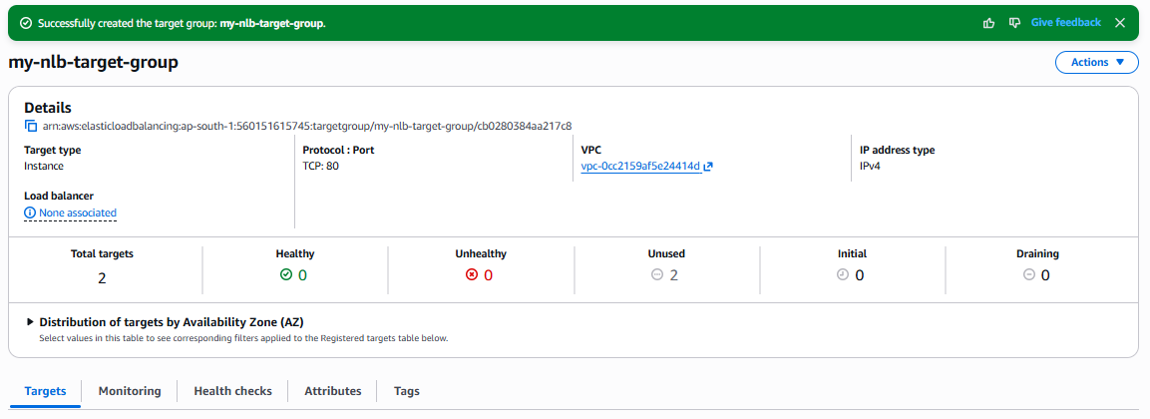

Step 6: Configure Health Check
For a TCP target group:
Health check protocol:
TCP
Health check port:
Traffic port
The NLB checks whether the target can accept TCP connections on port 80.
Conceptually:
NLB
|
+---- TCP health check ----> EC2-1 :80
|
+---- TCP health check ----> EC2-2 :80
Healthy targets:
EC2-1 → Healthy
EC2-2 → Healthy

Step 7: Register EC2 Instances
Select:
EC2-1
EC2-2
Port:
80
Click:
Include as pending below
Then:
Create target group
You should eventually see:
Target Group
|
+---- EC2-1 :80 → Healthy
|
+---- EC2-2 :80 → Healthy

Step 8: Attach Target Group to NLB
Return to your NLB configuration.
For the listener:
TCP :80
Select:
Forward to:
my-nlb-target-group
So the complete flow is:
Client
|
| TCP :80
↓
NLB
|
| TCP
↓
Target Group
|
+------ EC2-1 :80
|
+------ EC2-2 :80

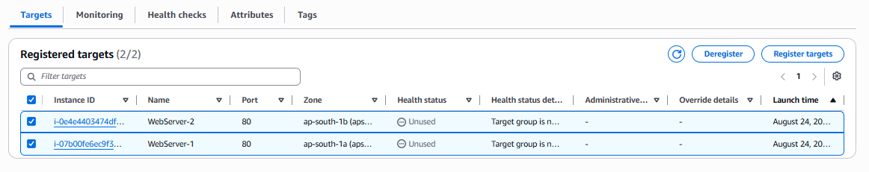

Step 9: Create NLB
Review the configuration.
Click:
Create Load Balancer
AWS creates the NLB.
You will get a DNS name similar to:
my-network-lb-123456789.ap-south-1.elb.amazonaws.com

Step 10: Test the NLB
Open the NLB DNS name:
http://<NLB-DNS-NAME>
You may receive:
Hello from NLB Server 1
or:
Hello from NLB Server 2
You can also test from the command line:
curl http://<NLB-DNS-NAME>
Run it multiple times to observe traffic reaching the registered targets.

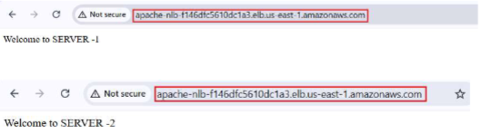

Step 11: Check Target Health
Go to:
EC2 → Target Groups → my-nlb-target-group → Targets
You should see:
Instance Port Health
------------------------------------
EC2-1 80 Healthy
EC2-2 80 Healthy

Step 12: Test NLB Health Check
Stop Apache on EC2-1:
sudo systemctl stop httpd
Wait for the health check.
You should eventually see:
EC2-1 → Unhealthy
EC2-2 → Healthy
The NLB will stop sending new connections to EC2-1.
Start Apache again:
sudo systemctl start httpd
After the health check succeeds:
EC2-1 → Healthy
EC2-2 → Healthy

4. NLB Supports TCP, UDP and TLS
One major advantage of NLB is that it can handle protocols such as:
TCP
UDP
TLS
For example:

TCP
Client
|
| TCP :8080
↓
NLB
|
↓
Application servers

UDP
Useful for applications such as DNS, gaming, streaming, and other UDP-based services.
Client
|
| UDP
↓
NLB
|
↓
UDP application servers

TLS
NLB can also terminate TLS when configured with a certificate, or pass encrypted traffic through depending on the architecture.
Client
|
| TLS :443
↓
NLB
|
↓
Target servers

5. NLB vs ALB
Feature | ALB | NLB
OSI Layer | Layer 7 | Layer 4
Main protocols | HTTP/HTTPS | TCP/UDP/TLS
URL-based routing | ✅ Yes | ❌ No
Host-based routing | ✅ Yes | ❌ No
Very high performance | Good | Excellent
Static IP | Not the typical choice | ✅ Supported
Web applications | ✅ Excellent | Possible
TCP applications | ❌ | ✅
UDP applications | ❌ | ✅
Health checks | ✅ | ✅

6. Final Architecture
Internet
|
|
TCP :80
|
↓
+-----------------------+
| Network Load Balancer |
| NLB |
+-----------+-----------+
|
Target Group
/ \
/ \
↓ ↓
+-----------+ +-----------+
| EC2-1 | | EC2-2 |
| Apache | | Apache |
| TCP :80 | | TCP :80 |
+-----------+ +-----------+
↑ ↑
| |
+---- Health ----+
Checks

Expected Result
After completing the task:
- ✅ NLB created
- ✅ NLB configured as internet-facing
- ✅ Two Availability Zones configured
- ✅ TCP listener created on port 80
- ✅ Target Group created
- ✅ Two EC2 instances registered
- ✅ Health checks configured
- ✅ Targets showing Healthy
- ✅ Application accessible through NLB DNS
- ✅ Traffic distributed across healthy EC2 instances
- ✅ Failover tested by stopping Apache on one instance

4.Attach SSL Certificate to an Application Load Balancer

Objective :
The objective is to secure an Application Load Balancer (ALB) using an SSL/TLS certificate so that clients can access the application over HTTPS on port 443.
The typical traffic flow will be:
Client
|
| HTTPS :443
| Encrypted
↓
Application Load Balancer
|
| SSL/TLS termination
| HTTP :80
↓
Target Group
|
↓
EC2 / Web Server
With an HTTPS listener, the ALB terminates the TLS connection, decrypts the request, and can forward it to the targets using HTTP or HTTPS.

Prerequisites :
Before attaching SSL to the ALB, make sure you have:

AWS resources
- AWS account
- VPC
- At least 2 subnets in different Availability Zones
- EC2 instances running your application/web server
- Target Group
- Application Load Balancer
- Security Groups
- A domain name : stathum.sbs

SSL certificate
You need an SSL/TLS certificate for your domain.
The recommended approach is to use AWS Certificate Manager (ACM). AWS recommends ACM certificates for load balancers because ACM integrates directly with Elastic Load Balancing.

Important
The certificate's domain name must match the domain through which users access the application. For example:
Certificate:
www.stathum.sbs

User accesses:
https://www.stathum.sbs
A wildcard certificate such as:
*.stathum.sbs
can cover:
www.example.com
api.example.com
app.example.com
but does not cover the apex domain stathum.sbs

Architecture :

Internet
|
|
HTTPS :443
|
↓
+-------------------+
| Application Load |
| Balancer |
+-------------------+
|
SSL Termination
|
HTTP :80
|
↓
+----------------+
| Target Group |
+----------------+
/ \
/ \
↓ ↓
EC2 Instance 1 EC2 Instance 2
Apache Apache

Step-by-Step Implementation

Step 1: Prepare your domain
You need a domain such as:
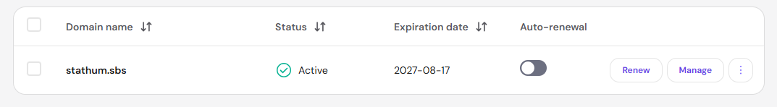
For practice, you can use a domain you already own.

Step 2: Open AWS Certificate Manager
Go to:
AWS Console → Certificate Manager (ACM)
Make sure you are in the same AWS Region as your Application Load Balancer. ACM certificates used with regional Elastic Load Balancing resources need to be in that Region.
Click:
Request a certificate

Step 3: Select Public Certificate
Select:
Request a public certificate
Click:
Next

Step 4: Enter Domain Name
For example:
www.stathum.sbs
You can also request:
example.com
or:
*.example.com
For a simple lab:
www.example.com
is enough.
Click:
Request

Step 5: Choose Validation Method
ACM will ask you to validate domain ownership.
Choose:
DNS validation
DNS validation is generally convenient because ACM can automatically renew eligible ACM certificates when the validation record remains in place.

Step 6: Create the DNS Validation Record
After requesting the certificate, ACM will show a DNS validation record.
You'll see something similar to:
Name:
_abc123.example.com

Type:
CNAME

Value:
_xyz456.acm-validations.aws.
If your DNS is hosted in Route 53, click:
Create records in Route 53
Otherwise, manually create the CNAME record with your DNS provider.

Step 7: Wait for Certificate Validation
Go back to:
ACM → Certificates
Initially, you may see:
Status: Pending validation
After DNS validation succeeds:
Status: Issued
You must wait until the certificate is Issued before attaching it to the ALB.
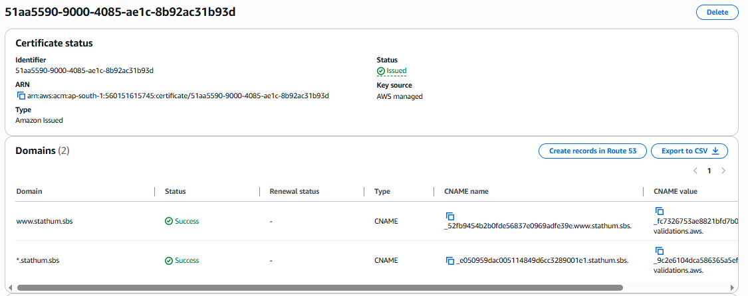

Step 8: Open EC2 Load Balancers
Go to:
AWS Console → EC2 → Load Balancers
Select your existing Application Load Balancer.
For example:
my-application-alb

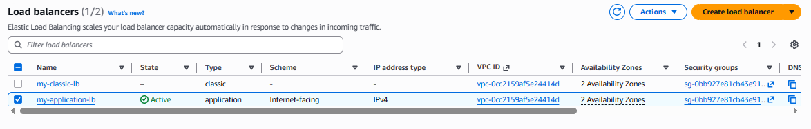

Step 9: Check the Existing HTTP Listener
Go to:
Listeners and rules
You may already have:
HTTP :80
with a default action such as:
Forward to:
my-target-group
Keep this listener if you want HTTP traffic to remain available or if you later plan to redirect HTTP → HTTPS.
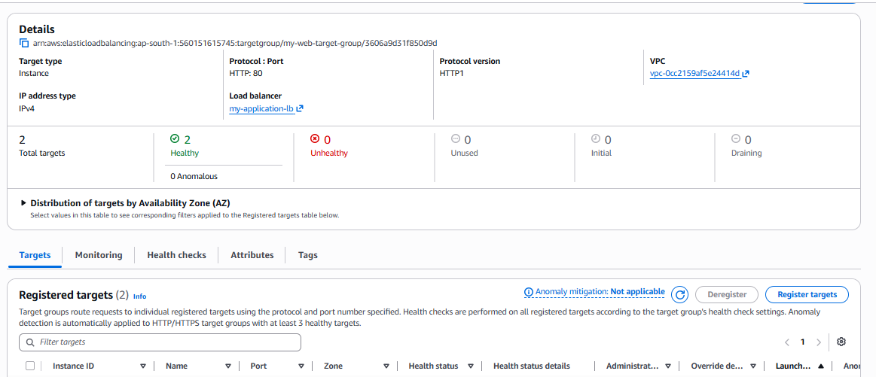

Step 10: Add HTTPS Listener
Click:
Add listener
Configure:
Protocol: HTTPS
Port: 443
An HTTPS listener requires at least one SSL/TLS server certificate and a security policy.

Step 11: Select SSL Certificate
Under:
Default SSL/TLS certificate
Choose:
From ACM
Then select your certificate:
www.example.com
The certificate should have:
Status: Issued
Click:
Add listener
AWS will use this certificate as the default certificate for the HTTPS listener.
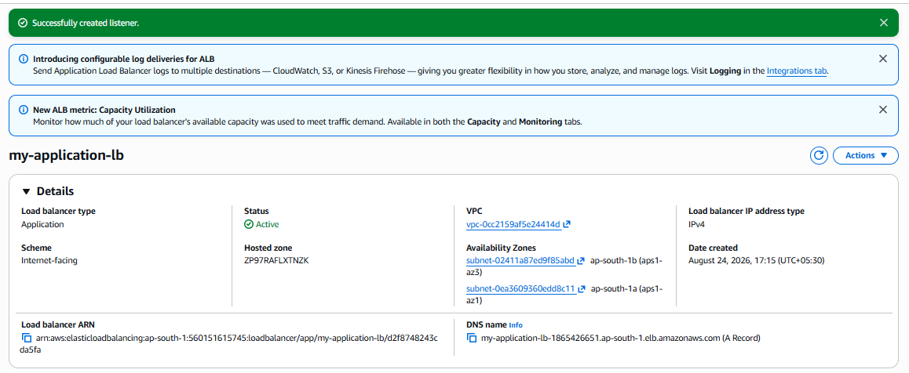

Step 12: Configure Default Action
For the HTTPS listener, configure:
Default action:
Forward to

Target group:
my-target-group
Example:
HTTPS :443
|
↓
my-target-group
|
↓
EC2 :80
AWS requires an available target group if you want the listener's default action to forward traffic.

Step 13: Configure Security Group
Your ALB Security Group should allow HTTPS.
For example:
Type | Protocol | Port | Source
HTTP | TCP | 80 | 0.0.0.0/0
HTTPS | TCP | 443 | 0.0.0.0/0
For production, you should restrict access according to your application's requirements.
Your EC2 Security Group should allow the application port from the ALB Security Group, rather than allowing the entire internet to reach the instances directly.
Example:
Internet
|
| TCP 443
↓
ALB Security Group
|
| TCP 80
↓
EC2 Security Group

Step 14: Test the HTTPS Listener
After the listener becomes active, access:
https://www.stathum.sbs
You should see your application.
The browser should show the HTTPS lock/security indicator if the certificate and DNS configuration are correct.

Step 15: Configure DNS to Point to the ALB
If you are using Route 53:
Go to:
Route 53 → Hosted zones → Your domain
Create an:
A record
Choose:
Alias: Yes
Target:
Application Load Balancer
Select your ALB.
Your final flow becomes:
www.example.com
|
| DNS
↓
Application Load Balancer
|
| HTTPS :443
↓
SSL Certificate
|
| TLS termination
↓
Target Group
|
| HTTP :80
↓
EC2

16. Optional: Redirect HTTP → HTTPS
For better security, you can redirect:
HTTP :80
↓
HTTPS :443
Go to:
ALB → Listeners and rules → HTTP :80 → Manage rules
Change the default action to:
Redirect to URL

Protocol: HTTPS
Port: 443
Status code: 301
Now:
http://www.example.com
automatically becomes:
https://www.example.com

17. Verify the Configuration
Check:

ACM
Certificate status: Issued
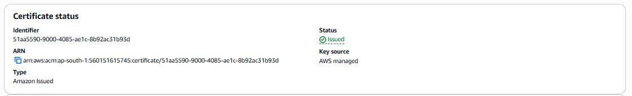

ALB
State: Active

Listener
HTTPS :443

Certificate
Default certificate: Your ACM certificate

Target Group
Health status: Healthy

DNS
www.example.com → ALB

Browser
https://www.example.com

18. Expected Final Configuration
Your ALB should look approximately like this:
Application Load Balancer
|
+---- HTTP :80
| |
| +---- Redirect → HTTPS :443
|
+---- HTTPS :443
|
+---- ACM SSL Certificate
|
+---- Forward
|
↓
Target Group
|
+------+------+
| |
↓ ↓
EC2-1 EC2-2
:80 :80

Key concept to remember
ACM does not itself encrypt your EC2 server traffic.
The important relationship is:
ACM Certificate
↓
HTTPS Listener :443
↓
Application Load Balancer
↓
Target Group
↓
EC2

TASK 5 : Map Application Load Balancer to Route 53

Objective :
The objective is to map a custom domain name to an AWS Application Load Balancer (ALB) using Amazon Route 53.
For example:
User
|
| https://www.stathum.sbs
↓
Route 53
|
| DNS resolution
↓
Application Load Balancer
|
↓
Target Group
|
+------ EC2-1 :80
|
+------ EC2-2 :80
After completing this configuration, users can access your application using:
https://www.stathum.sbs
instead of the AWS-generated ALB DNS name.

Prerequisites :
Before starting, make sure you have:

AWS resources
- AWS account
- Application Load Balancer
- At least one EC2 instance registered with the ALB
- Target Group
- Target Group targets showing Healthy
- HTTP listener on port 80
- HTTPS listener on port 443 if HTTPS is required
- ACM certificate for your domain
For your setup:
Domain:
stathum.sbs

Website:
www.stathum.sbs

ALB:
my-application-lb-1865426651

Route 53
You need a public hosted zone:
stathum.sbs

Domain
Your domain's nameservers must point to the Route 53 hosted zone.
You have already verified that yours are:
ns-1088.awsdns-08.org
ns-405.awsdns-50.com
ns-1573.awsdns-04.co.uk
ns-635.awsdns-15.net

Architecture
For HTTPS:
Internet
|
|
www.stathum.sbs
|
↓
Amazon Route 53
|
| A Alias
↓
Application Load Balancer
|
+----------+----------+
| |
HTTP :80 HTTPS :443
| |
Redirect ACM SSL
| |
+--------→ HTTPS ←----+
|
↓
Target Group
|
+------+------+
| |
↓ ↓
EC2-1 EC2-2
:80 :80

Step 1 — Open Route 53
Go to the AWS Console.
Open:
Route 53 → Hosted zones
You should see:
stathum.sbs
Click the hosted zone.

Step 2 — Verify the hosted zone
You should see the default records:
stathum.sbs NS
stathum.sbs SOA
If ACM DNS validation was configured, you may also see CNAME records such as:
_e050959...stathum.sbs
and:
_52fb945...www.stathum.sbs
These CNAME records are only for ACM validation.
Do not use them for ALB mapping.\
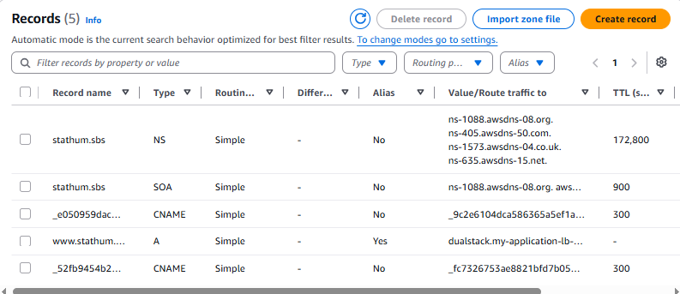

Step 3 — Create the ALB DNS record :
Click:
Create record
You will get the Route 53 record creation screen.
Configure it as follows.

Record name
Enter:
www
Because the hosted zone is:
stathum.sbs
Route 53 will create:
www.stathum.sbs

Step 4 — Select record type
Select:
Record type: A
Do not select CNAME for this ALB alias configuration.

Step 5 — Enable Alias :
Turn on:
Alias: ON
This is important.
You should now see:
Route traffic to
Select:
Alias to Application Load Balancer

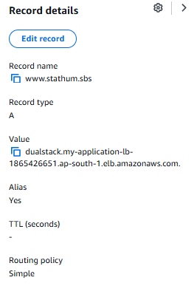

Step 6 — Select AWS Region
Select the region where your ALB exists.
Your ALB is in Mumbai:
Asia Pacific (Mumbai)
ap-south-1
So select:
ap-south-1

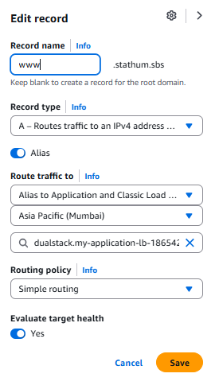

Step 7 — Select your ALB :
Route 53 should show your Application Load Balancer.
Select:
my-application-lb-1865426651
Your configuration should now look approximately like:
Record name:
www

Record type:
A

Alias:
Yes

Route traffic to:
Application Load Balancer

Region:
ap-south-1

Load Balancer:
my-application-lb-1865426651
Click:
Create records

Step 8 — Verify the record :
After creating it, your hosted zone should contain something similar to:
stathum.sbs
│
├── NS
├── SOA
│
├── _e050959...stathum.sbs
│ CNAME → ACM validation
│
├── _52fb945...www.stathum.sbs
│ CNAME → ACM validation
│
└── www
A
Alias: Yes
→ Application Load Balancer
This is the important record:
www
A
Alias → ALB

Step 9 — Verify DNS resolution
From your Linux machine, run:
nslookup www.stathum.sbs
or:
dig www.stathum.sbs
You should receive IP addresses associated with your ALB.
For example:
Name: www.stathum.sbs
Address: 15.x.x.x
Address: 13.x.x.x
The actual IP addresses can change because AWS manages the ALB addresses.

Important
Don't create an A record manually using those IP addresses.
Use:
A + Alias → ALB
because ALB IP addresses can change.
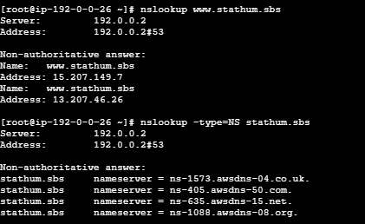

Step 10 — Verify the domain
Open:
https://www.stathum.sbs
The traffic should flow:
Browser
|
| HTTPS :443
↓
www.stathum.sbs
|
↓
Route 53
|
↓
ALB
|
| HTTPS :443
↓
ACM Certificate
|
↓
Target Group
|
| HTTP :80
↓
EC2
|
↓
Apache

14. If HTTP → HTTPS redirect is configured
If your ALB has:
HTTP :80
|
↓
Redirect
|
↓
HTTPS :443
then the user can enter:
http://www.stathum.sbs
and the ALB will redirect them to:
https://www.stathum.sbs
So the complete flow is:
http://www.stathum.sbs
|
↓
Route 53
|
↓
ALB :80
|
| 301 Redirect
↓
https://www.stathum.sbs
|
↓
ALB :443
|
↓
ACM Certificate
|
↓
Target Group
|
↓
EC2 :80

15. Security Groups
Make sure the ALB security group allows:
Inbound
--------------------------
HTTP TCP 80 0.0.0.0/0
HTTPS TCP 443 0.0.0.0/0
The EC2 security group should allow:
Inbound
--------------------------
HTTP TCP 80 ALB-Security-Group
So users don't need direct access to the EC2 instances.

16. Verification checklist
Before declaring the configuration complete, verify:
Component | Expected
Route 53 Hosted Zone | stathum.sbs
Domain | stathum.sbs
Website record | www
Record type | A
Alias | Yes
Alias target | Application Load Balancer
ALB region | ap-south-1
ALB state | Active
HTTP listener | 80
HTTPS listener | 443
ACM certificate | Issued
Target Group | Targets Healthy
EC2 application | Listening on 80
Website | https://www.stathum.sbs

Important distinction: ACM CNAME vs ALB Alias
This is where you encountered an error earlier.

ACM validation record
_e050959...stathum.sbs
|
↓
CNAME
|
↓
_acm-validation.aws
Purpose:
Prove ownership of the domain to ACM.

ALB Route 53 record
www.stathum.sbs
|
↓
A Record
Alias = Yes
|
↓
Application Load Balancer
Purpose:
Send website traffic to your ALB.
They are completely different.

Final configuration
For your lab, the final setup should be:
stathum.sbs
|
Route 53
|
www → A Alias
|
↓
Application Load Balancer
|
+-----------+-----------+
| |
HTTP :80 HTTPS :443
| |
Redirect ACM SSL
| |
+----------→ |
Forward
|
↓
Target Group
HTTP :80
/ \
↓ ↓
EC2-1 EC2-2
:80 :80
The key Route 53 configuration is simply:
Name: www
Type: A
Alias: Yes
Target: Your Application Load Balancer
Region: ap-south-1
Then access your application using https://www.stathum.sbs, not the ALB's *.elb.amazonaws.com hostname.

Push Application Load Balancer Logs to S3

Objective :
The objective is to enable Application Load Balancer (ALB) access logging and store the generated log files in an Amazon S3 bucket.
The logs help you monitor and troubleshoot:
- Client IP addresses
- Request paths
- HTTP response codes
- Request/response latency
- Target responses
- Traffic patterns
ALB access logs are optional and are disabled by default. When enabled, the ALB delivers compressed log files to the S3 bucket you specify. (AWS Documentation)

Architecture
Internet
|
↓
Application Load Balancer
|
|
Access Logs
|
↓
Amazon S3
|
↓
ALB log files (.log.gz)

Prerequisites :
Before starting, you need:

AWS resources
- AWS account
- Application Load Balancer already created
- ALB should be in ap-south-1 in your case
- S3 bucket
- Permission to modify the S3 bucket policy
- Permission to modify the ALB attributes

Important S3 requirements
For traditional ALB access logs:
- The S3 bucket must be in the same AWS Region as the ALB.
- The bucket must allow the Elastic Load Balancing log-delivery service to write objects.
- For this access-log configuration, use SSE-S3 rather than SSE-KMS.
- If using a prefix, don't include AWSLogs in the prefix. (AWS Documentation)
Therefore, because your ALB is in:
ap-south-1
create your logging bucket in:
Asia Pacific (Mumbai)
ap-south-1

Step 1 — Create the S3 bucket
Go to:
AWS Console → S3 → Create bucket
Choose a unique bucket name, for example:
stathum-alb-access-logs-2026
Bucket names must be globally unique, so if that name is unavailable, add some unique numbers.

AWS Region
Select:
Asia Pacific (Mumbai)
ap-south-1

Object Ownership
Leave the recommended setting:
ACLs disabled
Bucket owner enforced

Block Public Access
Keep:
Block all public access
✅ This is recommended because ALB logs don't need to be publicly accessible.

Default encryption
Choose:
SSE-S3
AWS documents SSE-S3 as the supported server-side encryption option for this ALB access-log configuration. (AWS Documentation)
Click:
Create bucket
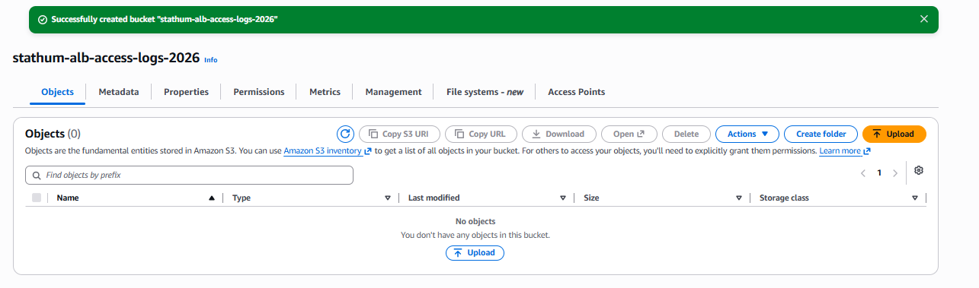

Step 2 — Find your AWS Account ID
You need your AWS account ID for the bucket policy.
You can find it from:
AWS Console → Account → Account ID
For example:
560151615745
Don't use that example value in your actual policy.
Use your actual 12-digit AWS account ID.

Step 3 — Add the S3 bucket policy
Open:
S3 → Your bucket → Permissions → Bucket policy → Edit
Add a policy like this:
{
"Version": "2012-10-17",
"Statement": [
{
"Effect": "Allow",
"Principal": {
"Service": "logdelivery.elasticloadbalancing.amazonaws.com"
},
"Action": "s3:PutObject",
"Resource": "arn:aws:s3:::YOUR-BUCKET-NAME/AWSLogs/YOUR-AWS-ACCOUNT-ID/*"
}
]
}
with your actual AWS account ID.
For example, if your bucket were:
stathum-alb-access-logs-2026
and your account ID were:
123456789012
the resource would be:
arn:aws:s3:::stathum-alb-access-logs-2026/AWSLogs/123456789012/*
AWS's current documentation uses the logdelivery.elasticloadbalancing.amazonaws.com service principal and requires the account ID in the AWSLogs path. (AWS Documentation)
Click:
Save changes
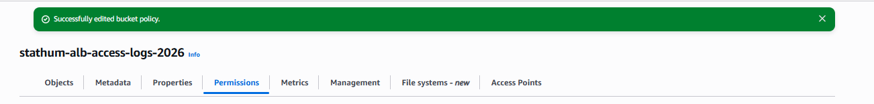

Step 4 — Go to your Application Load Balancer
Go to:
EC2 → Load Balancers
Select:
my-application-lb
Then open:
Attributes
Click:
Edit

Step 5 — Enable Access Logs
Find:
Monitoring → Access logs
Turn it:
OFF → ON
You should see an S3 URI field.
Enter:
s3://YOUR-BUCKET-NAME
For example:
s3://stathum-alb-access-logs-2026
You can optionally specify a prefix such as:
alb-logs
Then your logs will be organized under something like:
s3://stathum-alb-access-logs-2026/alb-logs/
Remember: don't put AWSLogs into the prefix yourself. AWS adds that portion automatically. (AWS Documentation)
Click:
Save changes

Step 6 — AWS validates the bucket
After enabling access logging, Elastic Load Balancing checks whether it can write to your S3 bucket.
AWS creates a test object:
ELBAccessLogTestFile
This is not an actual access log. It is simply a test file confirming that the ALB has permission to write to the bucket. (AWS Documentation)
Go to:
S3 → Your bucket
You should eventually see something similar to:
AWSLogs/
|
└── 123456789012/
|
└── ELBAccessLogTestFile
If you see the test file, that's a good sign.
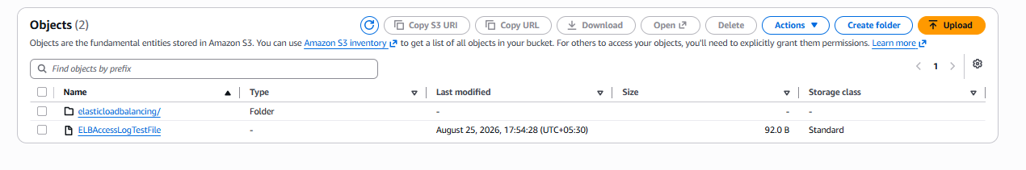

Step 7 — Generate some traffic
Now access your application several times.
For example:
https://www.stathum.sbs
Also try:
http://www.stathum.sbs
Your HTTP listener should redirect HTTP → HTTPS if you've configured that earlier.
You can also use:
curl -I https://www.stathum.sbs
Generate several requests so the ALB has traffic to log.
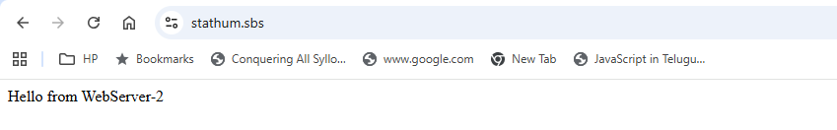


Step 8 — Check S3 for the ALB logs
Go to:
S3 → Your logging bucket
You should eventually see a structure similar to:
AWSLogs/
└── 123456789012/
└── elasticloadbalancing/
└── ap-south-1/
└── 2026/
└── 08/
└── 25/
└── ...
.log.gz
AWS publishes ALB access logs as compressed .log.gz files. Log delivery is eventually consistent, and ALB normally publishes a log file for each load-balancer node approximately every five minutes. (AWS Documentation)
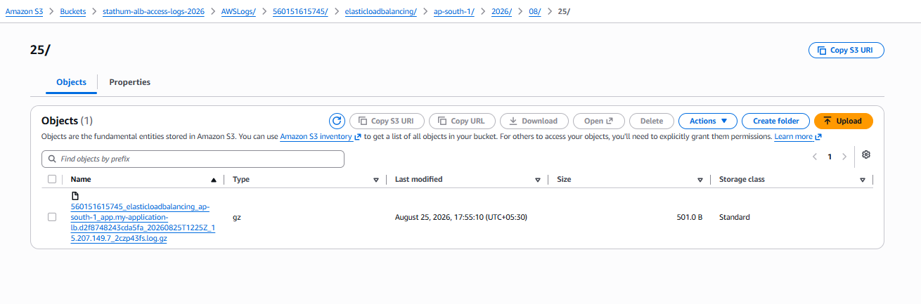
So don't expect the actual log immediately after making one request.

Step 9 — Download and inspect a log
Click one of the:
.log.gz
files and download it.
On Linux:
gunzip filename.log.gz
Then:
cat filename.log
or:
less filename.log
You can also search for HTTP 500 errors:
grep " 500 " filename.log
Or HTTP 404:
grep " 404 " filename.log

Final architecture
Your complete environment will look like:
USER
|
|
www.stathum.sbs
|
↓
Route 53
|
↓
+-----------------------+
| Application Load |
| Balancer |
| |
| HTTP :80 |
| ↓ |
| Redirect |
| ↓ |
| HTTPS :443 |
| ↓ |
| ACM Certificate |
+----------+------------+
|
| HTTP :80
↓
Target Group
/ \
↓ ↓
EC2-1 EC2-2
:80 :80
\ /
\ /
Apache

+
|
| Access Logs
↓
+-------------+
| Amazon S3 |
| |
| AWSLogs/ |
| Account/ |
| ALB logs |
+-------------+

Short version to remember
1. Create S3 bucket
↓
2. Same region as ALB
↓
3. Add S3 bucket policy
↓
4. EC2 → Load Balancers
↓
5. Select ALB → Attributes
↓
6. Enable Access Logs
↓
7. Enter S3 URI
↓
8. Save
↓
9. Generate traffic
↓
10. Check S3 → AWSLogs/

